ACSL
American Computer Science League
2012-2013

Contest #4

Intermediate Division Solutions

1. 6

- Data Structures
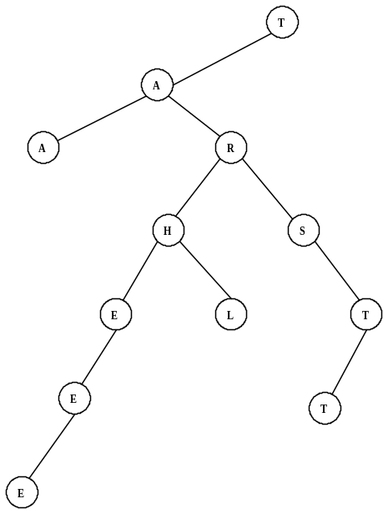

The binary search tree is shown on the right. The depth of the tree
is 6.

- Data Structures
The stack is constructed as follows:
R, RA, RAL, RALE, RAL, RA, RAI, RAIG, RAIGH, RAIG,
RAIGD, RAIGDU, RAIGD, RAIG, RAIGR, RAIGRH, RAIGR,
RAIGRM, RAIGR, RAIG, RAI. The next popped item is I since stacks are LIFO.
2. I

3. NONE
- Digital Electronics
The circuit translates to: 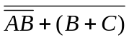
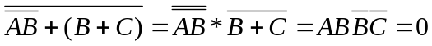
Therefore no triples make the circuit true.

4. 0
- Digital Electronics
The circuit translates to: 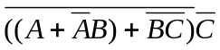
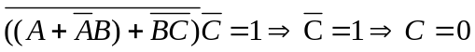
which is impossible. Therefore no ordered triples make it true.

5. LISP
(CAR(CAR(CDR(CDR(CDR ‘(1(2 3)4((5 6)(7 8)9)))))))
= (CAR(CAR(CDR(CDR ‘((2 3)4((5 6)(7 8)9))))))
= (CAR(CAR(CDR ‘(4((5 6)(7 8)9)))))
= (CAR(CAR ‘(((5 6)(7 8)9))))
= (CAR ‘((5 6)(7 8)))
= (5 6)

5. (5 6)

